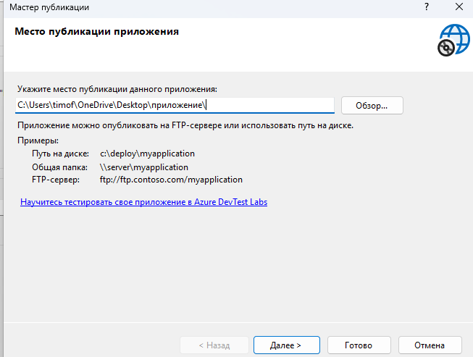
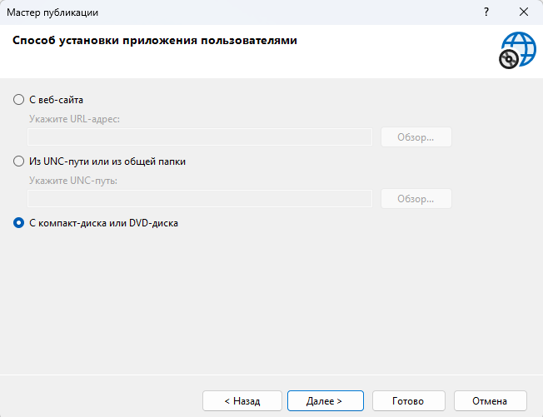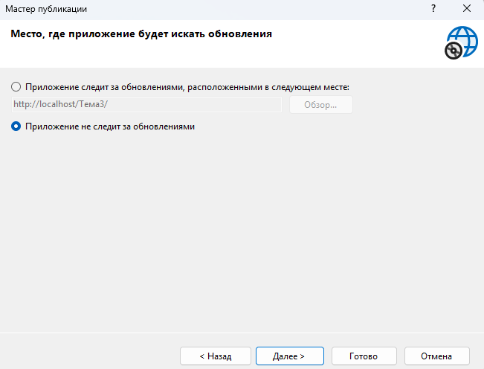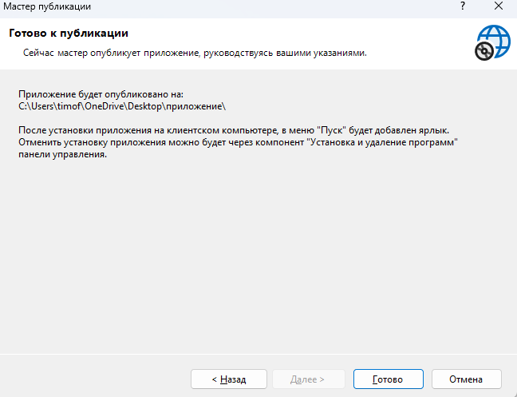
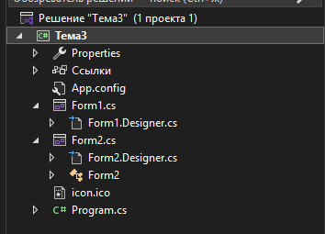
Структура проекта
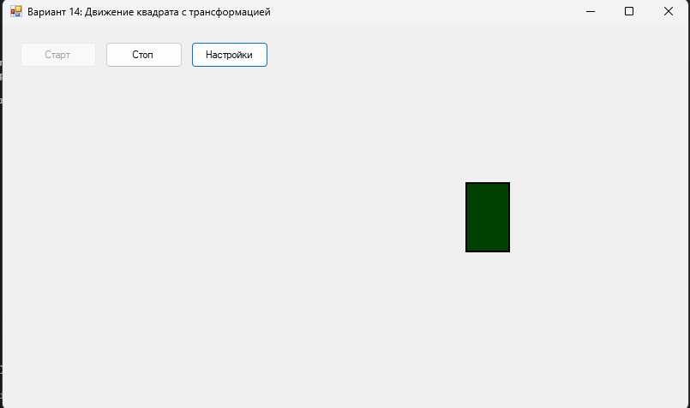
Можно менять цвет, скорость, кнопки старт стоп рабочие
Код Form1.cs:
using System;
using System.Drawing;
using System.Windows.Forms;

namespace WindowsFormsApp1
{
public partial class Form1 : Form
{
// Параметры фигуры
private RectangleF shapeRect; // Прямоугольник фигуры
private float shapeWidth = 50; // Ширина фигуры
private float shapeHeight = 50; // Высота фигуры
private Color shapeColor = Color.Blue; // Цвет фигуры

// Параметры движения
private float stepX = 2; // Шаг движения по X
private float minX = 10; // Минимальная позиция по X
private float maxX; // Максимальная позиция по X

// Параметры трансформации
private float currentHeight = 50; // Текущая высота
private float minHeight = 50; // Минимальная высота (квадрат)
private float maxHeight = 100; // Максимальная высота (прямоугольник)
private float heightStep = 0.5f; // Шаг изменения высоты
private bool expanding = true; // Растягиваемся или сжимаемся

// Таймер
private Timer animationTimer;

// Флаг для завершения программы
private bool isRunning = true;

public Form1()
{
InitializeComponent();

// Настройка таймера
animationTimer = new Timer();
animationTimer.Interval = 30;
animationTimer.Tick += AnimationTimer_Tick;

// Подписка на события клавиш
this.KeyPreview = true;
this.KeyDown += Form1_KeyDown;

// Инициализация позиции
InitializeShape();
}

private void InitializeShape()
{
// Начальная позиция - левая часть формы
minX = shapeWidth / 2 + 5;
maxX = this.ClientSize.Width - shapeWidth / 2 - 5;

float startX = minX;
float startY = this.ClientSize.Height / 2;

shapeRect = new RectangleF(
startX - shapeWidth / 2,
startY - currentHeight / 2,
shapeWidth,
currentHeight
);
}

private void AnimationTimer_Tick(object sender, EventArgs e)
{
// Движение по горизонтали
shapeRect.X += stepX;

// Проверка достижения границ
if (shapeRect.X <= minX)
{
shapeRect.X = minX;
stepX = Math.Abs(stepX);
}
else if (shapeRect.X + shapeRect.Width >= maxX + shapeRect.Width / 2)
{
shapeRect.X = maxX + shapeRect.Width / 2 - shapeRect.Width;
stepX = -Math.Abs(stepX);
}

// Трансформация высоты
if (expanding)
{
currentHeight += heightStep;
if (currentHeight >= maxHeight)
{
currentHeight = maxHeight;
expanding = false;
}
}
else
{
currentHeight -= heightStep;
if (currentHeight <= minHeight)
{
currentHeight = minHeight;
expanding = true;
}
}

// Обновление прямоугольника
shapeRect.Height = currentHeight;
shapeRect.Y = this.ClientSize.Height / 2 - currentHeight / 2;

// Перерисовка
this.Invalidate();
}

private void Form1_Paint(object sender, PaintEventArgs e)
{
// Рисование фигуры
using (SolidBrush brush = new SolidBrush(shapeColor))
{
e.Graphics.FillRectangle(brush, shapeRect);
}

// Рисование рамки
using (Pen pen = new Pen(Color.Black, 2))
{
e.Graphics.DrawRectangle(pen, Rectangle.Round(shapeRect));
}
}

private void Form1_KeyDown(object sender, KeyEventArgs e)
{
// Завершение при нажатии любой клавиши
if (isRunning)
{
animationTimer.Stop();
isRunning = false;
this.Close();
}
}

private void Form1_Resize(object sender, EventArgs e)
{
if (this.ClientSize.Width > 0 && this.ClientSize.Height > 0)
{
maxX = this.ClientSize.Width - shapeWidth / 2 - 10;

if (shapeRect != null)
{
if (shapeRect.X < minX)
shapeRect.X = minX;
if (shapeRect.X + shapeRect.Width > this.ClientSize.Width - minX)
shapeRect.X = this.ClientSize.Width - shapeRect.Width - minX;

shapeRect.Y = this.ClientSize.Height / 2 - currentHeight / 2;
}
}
}

private void btnStart_Click(object sender, EventArgs e)
{
animationTimer.Start();
btnStart.Enabled = false;
btnStop.Enabled = true;
}

private void btnStop_Click(object sender, EventArgs e)
{
animationTimer.Stop();
btnStart.Enabled = true;
btnStop.Enabled = false;
}

private void btnSettings_Click(object sender, EventArgs e)
{
Form2 settingsForm = new Form2(shapeColor, animationTimer.Interval);

if (settingsForm.ShowDialog() == DialogResult.OK)
{
shapeColor = settingsForm.SelectedColor;
animationTimer.Interval = settingsForm.Speed;
}
}

private void Form1_Load(object sender, EventArgs e)
{
animationTimer.Start();
btnStart.Enabled = false;
btnStop.Enabled = true;
}
}
}
Код Form1.designer.cs:
using System.Windows.Forms;

namespace WindowsFormsApp1
{
partial class Form1
{
private System.ComponentModel.IContainer components = null;
private Button btnStart;
private Button btnStop;
private Button btnSettings;

protected override void Dispose(bool disposing)
{
if (disposing && (components != null))
{
components.Dispose();
}
base.Dispose(disposing);
}

#region Windows Form Designer generated code

private void InitializeComponent()
{
this.btnStart = new System.Windows.Forms.Button();
this.btnStop = new System.Windows.Forms.Button();
this.btnSettings = new System.Windows.Forms.Button();
this.SuspendLayout();

// btnStart
this.btnStart.Location = new System.Drawing.Point(20, 20);
this.btnStart.Name = "btnStart";
this.btnStart.Size = new System.Drawing.Size(90, 30);
this.btnStart.TabIndex = 0;
this.btnStart.Text = "Старт";
this.btnStart.UseVisualStyleBackColor = true;
this.btnStart.Click += new System.EventHandler(this.btnStart_Click);

// btnStop
this.btnStop.Location = new System.Drawing.Point(120, 20);
this.btnStop.Name = "btnStop";
this.btnStop.Size = new System.Drawing.Size(90, 30);
this.btnStop.TabIndex = 1;
this.btnStop.Text = "Стоп";
this.btnStop.UseVisualStyleBackColor = true;
this.btnStop.Enabled = false;
this.btnStop.Click += new System.EventHandler(this.btnStop_Click);

// btnSettings
this.btnSettings.Location = new System.Drawing.Point(220, 20);
this.btnSettings.Name = "btnSettings";
this.btnSettings.Size = new System.Drawing.Size(90, 30);
this.btnSettings.TabIndex = 2;
this.btnSettings.Text = "Настройки";
this.btnSettings.UseVisualStyleBackColor = true;
this.btnSettings.Click += new System.EventHandler(this.btnSettings_Click);

// Form1
this.AutoScaleDimensions = new System.Drawing.SizeF(6F, 13F);
this.AutoScaleMode = System.Windows.Forms.AutoScaleMode.Font;
this.ClientSize = new System.Drawing.Size(800, 450);
this.Controls.Add(this.btnSettings);
this.Controls.Add(this.btnStop);
this.Controls.Add(this.btnStart);
this.DoubleBuffered = true;
this.Name = "Form1";
this.StartPosition = System.Windows.Forms.FormStartPosition.CenterScreen;
this.Text = "Вариант 14: Движение квадрата с трансформацией";
this.Paint += new System.Windows.Forms.PaintEventHandler(this.Form1_Paint);
this.Resize += new System.EventHandler(this.Form1_Resize);
this.Load += new System.EventHandler(this.Form1_Load);
this.KeyDown += new System.Windows.Forms.KeyEventHandler(this.Form1_KeyDown);
this.ResumeLayout(false);
this.PerformLayout();
}

#endregion
}
}
Код Form2.cs:
using System;
using System.Drawing;
using System.Windows.Forms;

namespace WindowsFormsApp1
{
public partial class Form2 : Form
{
private ColorDialog colorDialog;
private Timer speedPreviewTimer;
private int currentSpeed;
private Color currentColor;

public Color SelectedColor { get; private set; }
public int Speed { get; private set; }

public Form2(Color initialColor, int initialSpeed)
{
InitializeComponent();

currentColor = initialColor;
currentSpeed = initialSpeed;

SelectedColor = initialColor;
Speed = initialSpeed;

// Отображение текущих значений
UpdateColorDisplay();
trackBarSpeed.Value = initialSpeed;
lblSpeedValue.Text = $"{initialSpeed} мс";

// Таймер для предпросмотра
speedPreviewTimer = new Timer();
speedPreviewTimer.Interval = initialSpeed;
speedPreviewTimer.Tick += SpeedPreviewTimer_Tick;

colorDialog = new ColorDialog();
}

private void UpdateColorDisplay()
{
panelColor.BackColor = currentColor;
lblColor.Text = $"Текущий цвет: {currentColor.Name}";
}

private void SpeedPreviewTimer_Tick(object sender, EventArgs e)
{
// Мигание панели для предпросмотра скорости
panelPreview.BackColor = panelPreview.BackColor == Color.Red ?
Color.Transparent : Color.Red;
}

private void btnSelectColor_Click(object sender, EventArgs e)
{
colorDialog.Color = currentColor;

if (colorDialog.ShowDialog() == DialogResult.OK)
{
currentColor = colorDialog.Color;
UpdateColorDisplay();
}
}

private void trackBarSpeed_Scroll(object sender, EventArgs e)
{
currentSpeed = trackBarSpeed.Value;
lblSpeedValue.Text = $"{currentSpeed} мс";

// Обновление предпросмотра
speedPreviewTimer.Interval = currentSpeed;
}

private void btnPreview_Click(object sender, EventArgs e)
{
if (btnPreview.Text == "Предпросмотр")
{
speedPreviewTimer.Start();
btnPreview.Text = "Стоп";
}
else
{
speedPreviewTimer.Stop();
panelPreview.BackColor = Color.Transparent;
btnPreview.Text = "Предпросмотр";
}
}

private void btnOK_Click(object sender, EventArgs e)
{
SelectedColor = currentColor;
Speed = currentSpeed;

speedPreviewTimer.Stop();
this.DialogResult = DialogResult.OK;
this.Close();
}

private void btnCancel_Click(object sender, EventArgs e)
{
speedPreviewTimer.Stop();
this.DialogResult = DialogResult.Cancel;
this.Close();
}

private void Form2_FormClosing(object sender, FormClosingEventArgs e)
{
speedPreviewTimer.Stop();
}
}
}
Код Form2.designer.cs:
using System.Windows.Forms;

namespace WindowsFormsApp1
{
partial class Form2
{
private System.ComponentModel.IContainer components = null;
private Panel panelColor;
private Label lblColor;
private Button btnSelectColor;
private Label lblSpeed;
private TrackBar trackBarSpeed;
private Label lblSpeedValue;
private Button btnPreview;
private Panel panelPreview;
private Button btnOK;
private Button btnCancel;

protected override void Dispose(bool disposing)
{
if (disposing && (components != null))
{
components.Dispose();
}
base.Dispose(disposing);
}

#region Windows Form Designer generated code

private void InitializeComponent()
{
this.panelColor = new System.Windows.Forms.Panel();
this.lblColor = new System.Windows.Forms.Label();
this.btnSelectColor = new System.Windows.Forms.Button();
this.lblSpeed = new System.Windows.Forms.Label();
this.trackBarSpeed = new System.Windows.Forms.TrackBar();
this.lblSpeedValue = new System.Windows.Forms.Label();
this.btnPreview = new System.Windows.Forms.Button();
this.panelPreview = new System.Windows.Forms.Panel();
this.btnOK = new System.Windows.Forms.Button();
this.btnCancel = new System.Windows.Forms.Button();
((System.ComponentModel.ISupportInitialize)(this.trackBarSpeed)).BeginInit();
this.SuspendLayout();

// panelColor
this.panelColor.BorderStyle = System.Windows.Forms.BorderStyle.FixedSingle;
this.panelColor.Location = new System.Drawing.Point(20, 30);
this.panelColor.Name = "panelColor";
this.panelColor.Size = new System.Drawing.Size(50, 50);
this.panelColor.TabIndex = 0;

// lblColor
this.lblColor.AutoSize = true;
this.lblColor.Location = new System.Drawing.Point(80, 30);
this.lblColor.Name = "lblColor";
this.lblColor.Size = new System.Drawing.Size(100, 13);
this.lblColor.TabIndex = 1;
this.lblColor.Text = "Текущий цвет: Blue";

// btnSelectColor
this.btnSelectColor.Location = new System.Drawing.Point(80, 50);
this.btnSelectColor.Name = "btnSelectColor";
this.btnSelectColor.Size = new System.Drawing.Size(120, 30);
this.btnSelectColor.TabIndex = 2;
this.btnSelectColor.Text = "Выбрать цвет";
this.btnSelectColor.UseVisualStyleBackColor = true;
this.btnSelectColor.Click += new System.EventHandler(this.btnSelectColor_Click);

// lblSpeed
this.lblSpeed.AutoSize = true;
this.lblSpeed.Location = new System.Drawing.Point(20, 100);
this.lblSpeed.Name = "lblSpeed";
this.lblSpeed.Size = new System.Drawing.Size(98, 13);
this.lblSpeed.TabIndex = 3;
this.lblSpeed.Text = "Скорость (мс/кадр):";

// trackBarSpeed
this.trackBarSpeed.Location = new System.Drawing.Point(20, 120);
this.trackBarSpeed.Minimum = 1;
this.trackBarSpeed.Maximum = 100;
this.trackBarSpeed.Name = "trackBarSpeed";
this.trackBarSpeed.Size = new System.Drawing.Size(200, 45);
this.trackBarSpeed.TabIndex = 4;
this.trackBarSpeed.TickFrequency = 10;
this.trackBarSpeed.Scroll += new System.EventHandler(this.trackBarSpeed_Scroll);

// lblSpeedValue
this.lblSpeedValue.AutoSize = true;
this.lblSpeedValue.Location = new System.Drawing.Point(230, 120);
this.lblSpeedValue.Name = "lblSpeedValue";
this.lblSpeedValue.Size = new System.Drawing.Size(31, 13);
this.lblSpeedValue.TabIndex = 5;
this.lblSpeedValue.Text = "30 мс";

// btnPreview
this.btnPreview.Location = new System.Drawing.Point(20, 170);
this.btnPreview.Name = "btnPreview";
this.btnPreview.Size = new System.Drawing.Size(100, 30);
this.btnPreview.TabIndex = 6;
this.btnPreview.Text = "Предпросмотр";
this.btnPreview.UseVisualStyleBackColor = true;
this.btnPreview.Click += new System.EventHandler(this.btnPreview_Click);

// panelPreview
this.panelPreview.BorderStyle = System.Windows.Forms.BorderStyle.FixedSingle;
this.panelPreview.Location = new System.Drawing.Point(130, 170);
this.panelPreview.Name = "panelPreview";
this.panelPreview.Size = new System.Drawing.Size(90, 30);
this.panelPreview.TabIndex = 7;

// btnOK
this.btnOK.Location = new System.Drawing.Point(80, 220);
this.btnOK.Name = "btnOK";
this.btnOK.Size = new System.Drawing.Size(80, 30);
this.btnOK.TabIndex = 8;
this.btnOK.Text = "OK";
this.btnOK.UseVisualStyleBackColor = true;
this.btnOK.Click += new System.EventHandler(this.btnOK_Click);

// btnCancel
this.btnCancel.Location = new System.Drawing.Point(170, 220);
this.btnCancel.Name = "btnCancel";
this.btnCancel.Size = new System.Drawing.Size(80, 30);
this.btnCancel.TabIndex = 9;
this.btnCancel.Text = "Отмена";
this.btnCancel.UseVisualStyleBackColor = true;
this.btnCancel.Click += new System.EventHandler(this.btnCancel_Click);

// Form2
this.AutoScaleDimensions = new System.Drawing.SizeF(6F, 13F);
this.AutoScaleMode = System.Windows.Forms.AutoScaleMode.Font;
this.ClientSize = new System.Drawing.Size(300, 280);
this.Controls.Add(this.btnCancel);
this.Controls.Add(this.btnOK);
this.Controls.Add(this.panelPreview);
this.Controls.Add(this.btnPreview);
this.Controls.Add(this.lblSpeedValue);
this.Controls.Add(this.trackBarSpeed);
this.Controls.Add(this.lblSpeed);
this.Controls.Add(this.btnSelectColor);
this.Controls.Add(this.lblColor);
this.Controls.Add(this.panelColor);
this.FormBorderStyle = System.Windows.Forms.FormBorderStyle.FixedDialog;
this.MaximizeBox = false;
this.MinimizeBox = false;
this.Name = "Form2";
this.StartPosition = System.Windows.Forms.FormStartPosition.CenterParent;
this.Text = "Настройки";
this.FormClosing += new System.Windows.Forms.FormClosingEventHandler(this.Form2_FormClosing);
((System.ComponentModel.ISupportInitialize)(this.trackBarSpeed)).EndInit();
this.ResumeLayout(false);
this.PerformLayout();
}

#endregion
}
}

